YOLOV8-BASED HELMET DETECTION & FINE SYSTEM
Author: Charulatha G [Team 2]

Project Type: individual project

Git Repo Link: https://github.com/Charulatha2005/YOLOv8-Based-Helmet-Detection-Fine-System

EXECUTIVE SUMMARY:
The Helmet Detection and Fine System is a computer vision–based application designed to automatically detect whether individuals in a video are wearing helmets and issue fines for violations. The system leverages pre-trained YOLOv8 models to detect persons and helmets in real-time, focusing on the head region to optimize detection accuracy.
Using YOLOv8 for both person detection and helmet classification, the system analyzes video frames, identifies the presence or absence of helmets, and annotates each person with a corresponding status message. Violations trigger a warning label indicating a fine, while compliant individuals are marked as helmet OK. The application also visually highlights the detected person and head region for clarity.

PROJECT OVERVIEW:

Objective

To develop an automated system that monitors safety compliance by detecting helmet usage among individuals in video footage and issuing fines for violations.

Scope
• Capture video frames from an input source (video file or camera)
• Detect persons in each frame using a YOLOv8 person detection model
• Crop the head region of each detected person for focused helmet analysis
• Detect helmets using a dedicated YOLOv8 helmet detection model
• Annotate frames with compliance status and fines
• Display results in real-time with clear visual indicators

KEY FEATURES
• Video-Based Monitoring
Processes video streams to identify and track multiple individuals in real-time.
• Head Region Analysis
Focuses helmet detection on the top portion of the person’s bounding box for better accuracy.
• Real-Time Helmet Classification
Differentiates between helmeted and non-helmeted individuals, issuing automated warnings or fines.
• Visual Annotations
Draws bounding boxes around detected persons and head regions, along with status labels and fine information.
• Dynamic Labeling
Automatically assigns unique IDs to individuals and updates helmet compliance status per frame.

TECHNICAL IMPLEMENTATION:

Technology Stack:
Programming Language: Python
Computer Vision Framework: OpenCV
Object Detection Models: YOLOv8 (Ultralytics)
Video Handling: OpenCV VideoCapture and display functions
Performance Metrics:
Detection Accuracy: Assessed for correct person and helmet detection
Compliance Accuracy: Measures correct identification of helmet violations
Processing Speed: Real-time frame analysis depending on hardware capabilities

SOURCE CODE IMPLEMENTATION:
- Python script integrating YOLOv8 models for person and helmet detection
- Frame-by-frame processing with bounding boxes and text annotations
CONSTRAINTS:
- Detection accuracy is dependent on video quality, lighting, and angle
- Head cropping may miss helmets in extreme poses or occlusions
- Real-time performance may be limited by hardware or large video resolution
- Cannot detect non-standard helmets not present in training data
SOURCE CODE IMPLEMENTATION (Screenshot):
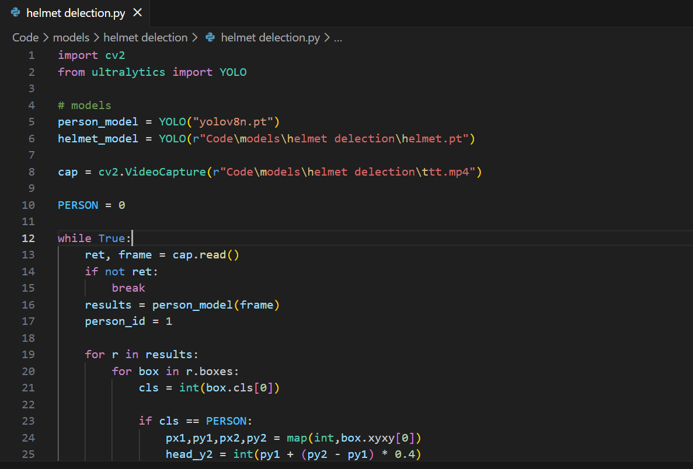

OUTPUT:
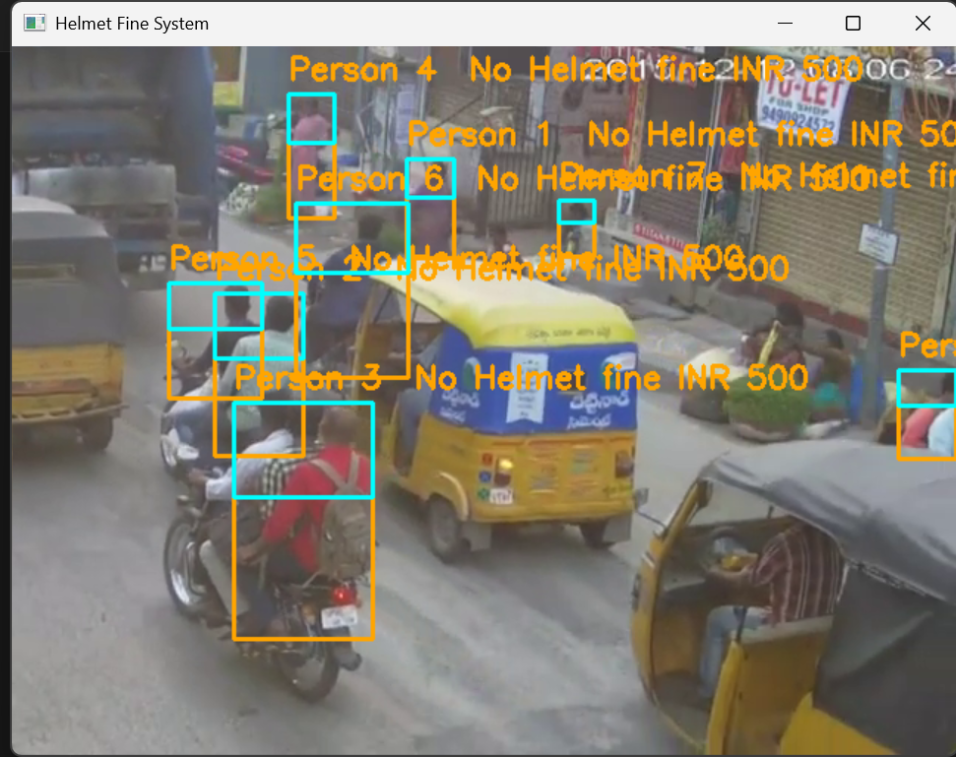

CONSTRAINTS:

Resource Constraints:
• Detection accuracy is dependent on video quality, lighting, and angle
• Head cropping may miss helmets in extreme poses or occlusions
• Real-time performance may be limited by hardware or large video resolution
• Cannot detect non-standard helmets not present in training data

PROJECT IMPACT AND VALUE:

Immediate Benefits
Automates helmet compliance monitoring
Reduces manual supervision effort
Enhances safety enforcement and accountability
Provides clear visual proof for violations
Long-Term Potential:
Can be integrated with traffic surveillance or workplace safety systems
Extendable to detect other safety gear (e.g., vests, gloves)
Potential for AI-powered analytics on compliance trends
Scalable for multi-camera setups or large video datasets

CONCLUSION:
The Helmet Detection and Fine System demonstrates an effective application of computer vision and object detection for real-time safety compliance monitoring. By leveraging YOLOv8 models for precise person and helmet detection, the system delivers actionable insights and enforcement capabilities. With further improvements in model accuracy and video integration, it can serve as a robust tool for industrial, traffic, or workplace safety monitoring.

